DEPLOYING WORDPRESS WEB APPLICATION USING DOCKER IN AMAZON WEB SERVICES

Steps to creating the infrastructure in this pipeline/module:

\*creating and launching an ec2 instance with AMI-Amazon linux2

\*Installing GIT , Docker and related repos

\*creating docker images with the help of YAML scripting

WHAT IS AWS?

AWS is the world most comprehensive and broadly adopted cloud platform, offering over 200 fully featured services from data centres globally millions of customers-including the fastest-growing startsups ,largest enterprises, and leading government agencies-are using AWS to lower costs become more agile and innovate faster.

What is git?

Git is version control system for tracking changes in computer files and is used to help coordinate work among several people on a project while tracking progress overtime. In other words, it’s a tool that facilitates source code management in software development.

What is wordpress?

WordPress is a free and open-source content management system written in hypertext preprocessor language and paired with a MySQL or MariaDB database with supported HTTPS. Features include a plugin architecture and a template system, referred to within WordPress as "Themes”.

What is docker?

Docker is a set of platform as a service products that use OS-level virtualization to deliver software in packages called containers. The service has both free and premium tiers. The software that hosts the containers is called Docker Engine.

MODULE-1

Ec2 instance-elastic compute cloud is virtual machine in the cloud on which you have os-level control. You can run this cloud server whenever you want and can be used when you need to deploy your own servers in the cloud .similar to your on premises server and when you want to have full control over the choice of hardware and the updates on the machine.

Login into the aws console with the help of IAM user. OS as a linux and attach the server to the security groups https , ssh and http.

Connect the server to the terminal by using the key pair.

MODULE-2

Connect the server to the terminal.

After update the system with the help of the below command.

🡪 sudo yum update

And after install the docker--- sudo yum -y install docker.

And next install the git—sudo yum -y install git

Give the permissions to the docker to add a limited linux user account by using the command.

Sudo usermod -a -G docker ec2-user.

And after start the docker service.

use the below command to get the docker service up automatically after reboot (instead of enable the service we use this command)

sudo chkconfig docker on

Install docker-compose:

Install docker-compose on the amazon linux by using the below command and install the latest version

sudo curl -L https://github.com/docker/compose/releases/download/1.22.0/docker-compose-$(uname -s)-$(uname -m) -o /usr/local/bin/docker-compose

And then give the executable permissions to the docker-compose.

Sudo chmod +x /usr/local/bin/docker-compose

Create a symbolic link:

It is a file whose purpose is to point to a file or a directory by specifying a path thereto.

Sudo ln -s /usr/local/bin/docker-compose /usr/bin/docker-compose

And check the version of the docker by using the command.

Docker-compose –version

And then create one docker-compose yaml file

--sudo vi docker-compose.yaml and write the script and save it.

And check the file by using command

Sudo docker-compose up -d i.e we pulling the MYSQL images through wordpress.

And after see the container list

Sudo docker-compose ps

And then copy paste the public ip adress on browser

DEPLOY WORDPRESS APPLICATION BY USING THE UBUNTU SERVER

Login into the aws console and launch the instance.

And connect the terminal to the instance

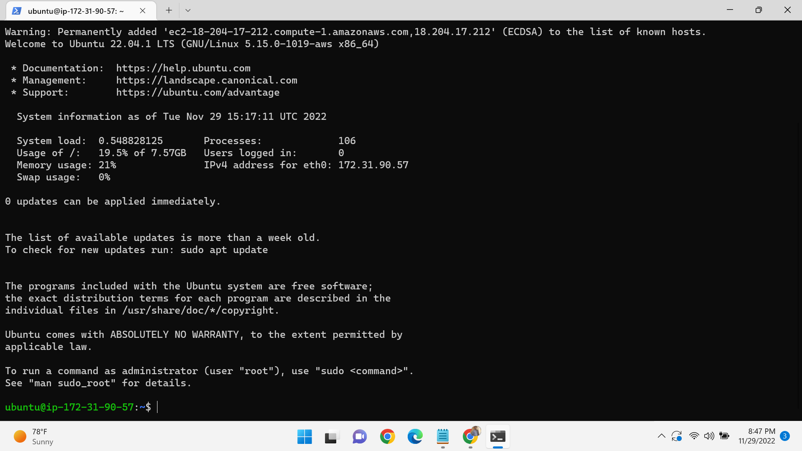

And update the server with the help of the following command

Sudo apt-get update

And install git-sudo apt-get install git

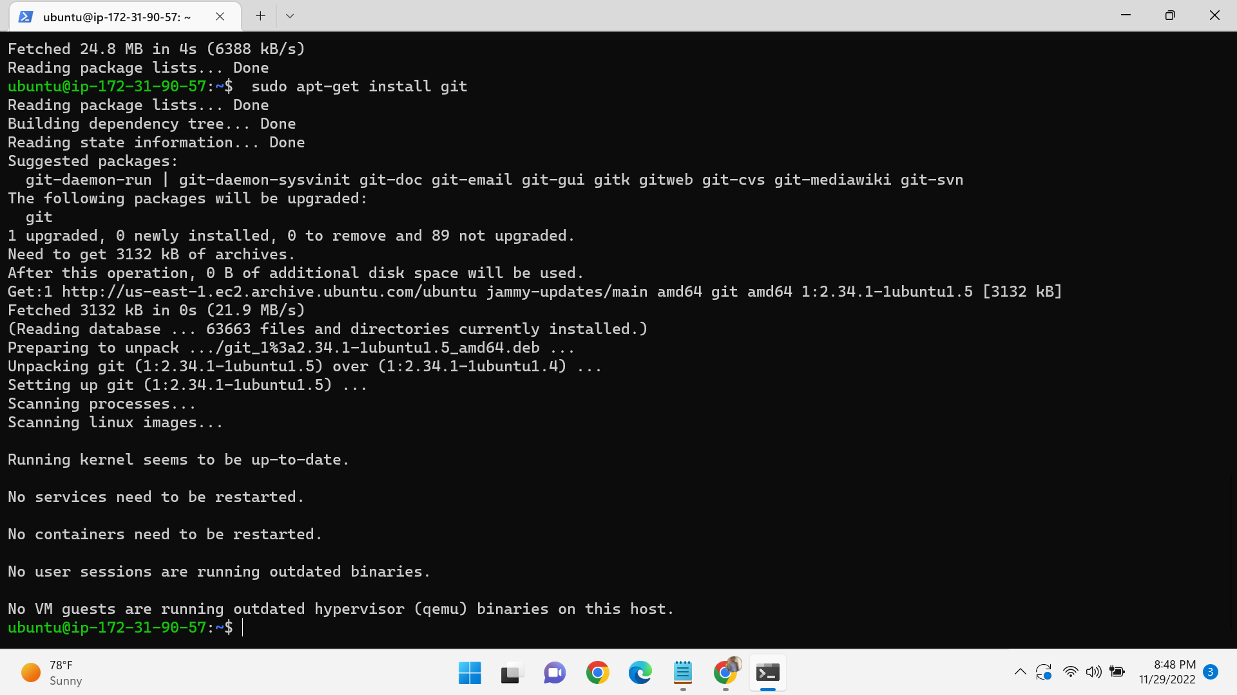

Install the docker in the terminal by using the command

Sudo apt install docker

Know the version of the docker-docker—version

Start the docker service and install the curl command in the ubuntu machine

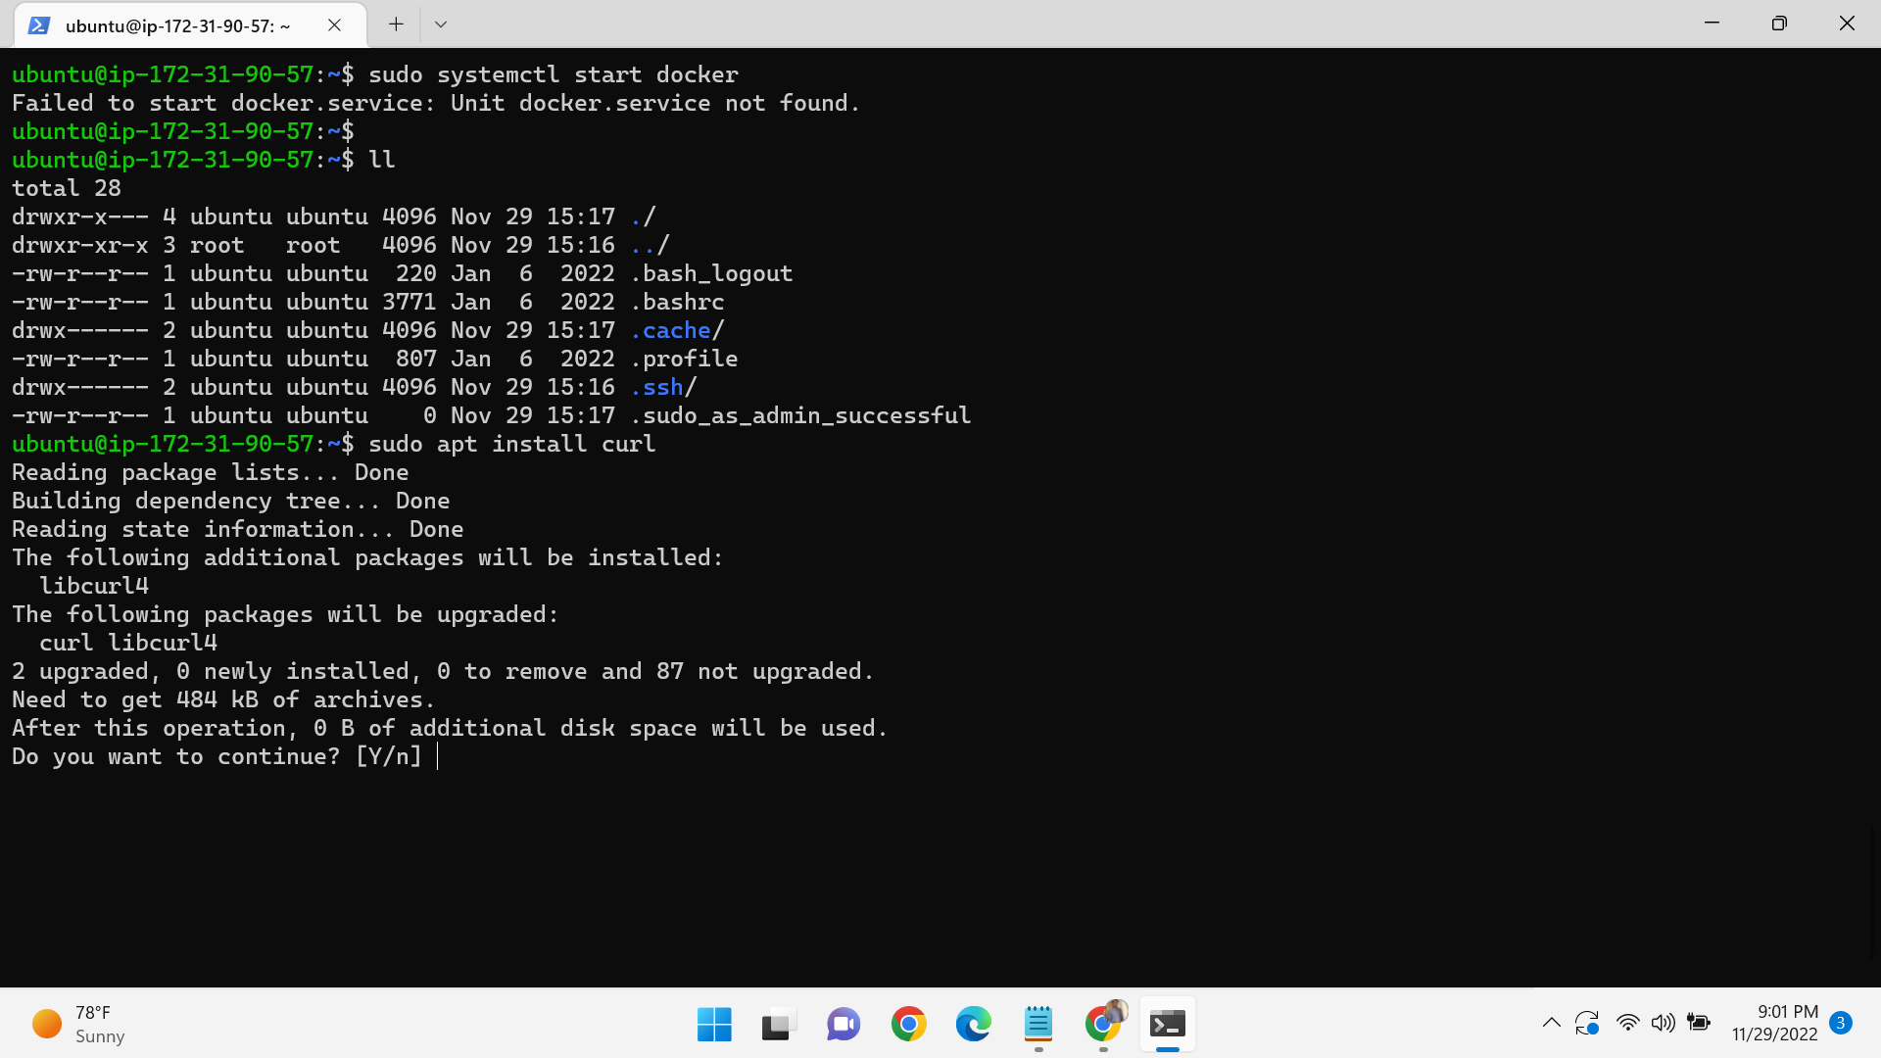

Install docker-compose on the ubuntu by using the below command and install the latest version

sudo curl -L https://github.com/docker/compose/releases/download/1.22.0/docker-compose-$(uname -s)-$(uname -m) -o /usr/local/bin/docker-compose

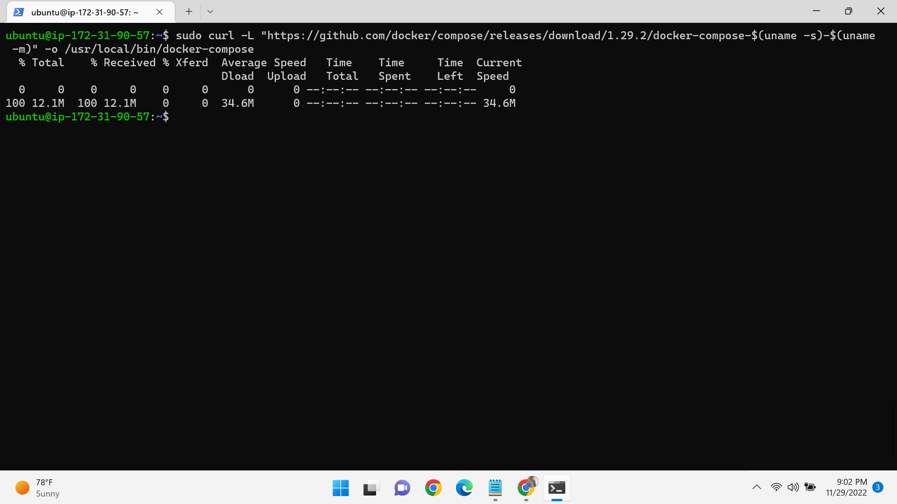

And then give the executable permissions to the docker-compose.

Sudo chmod +x /usr/local/bin/docker-compose

And check the version of the docker by using the command.

Docker-compose –version

And then create one docker-compose yaml file

--sudo vi docker-compose.yaml and write the script and save it.

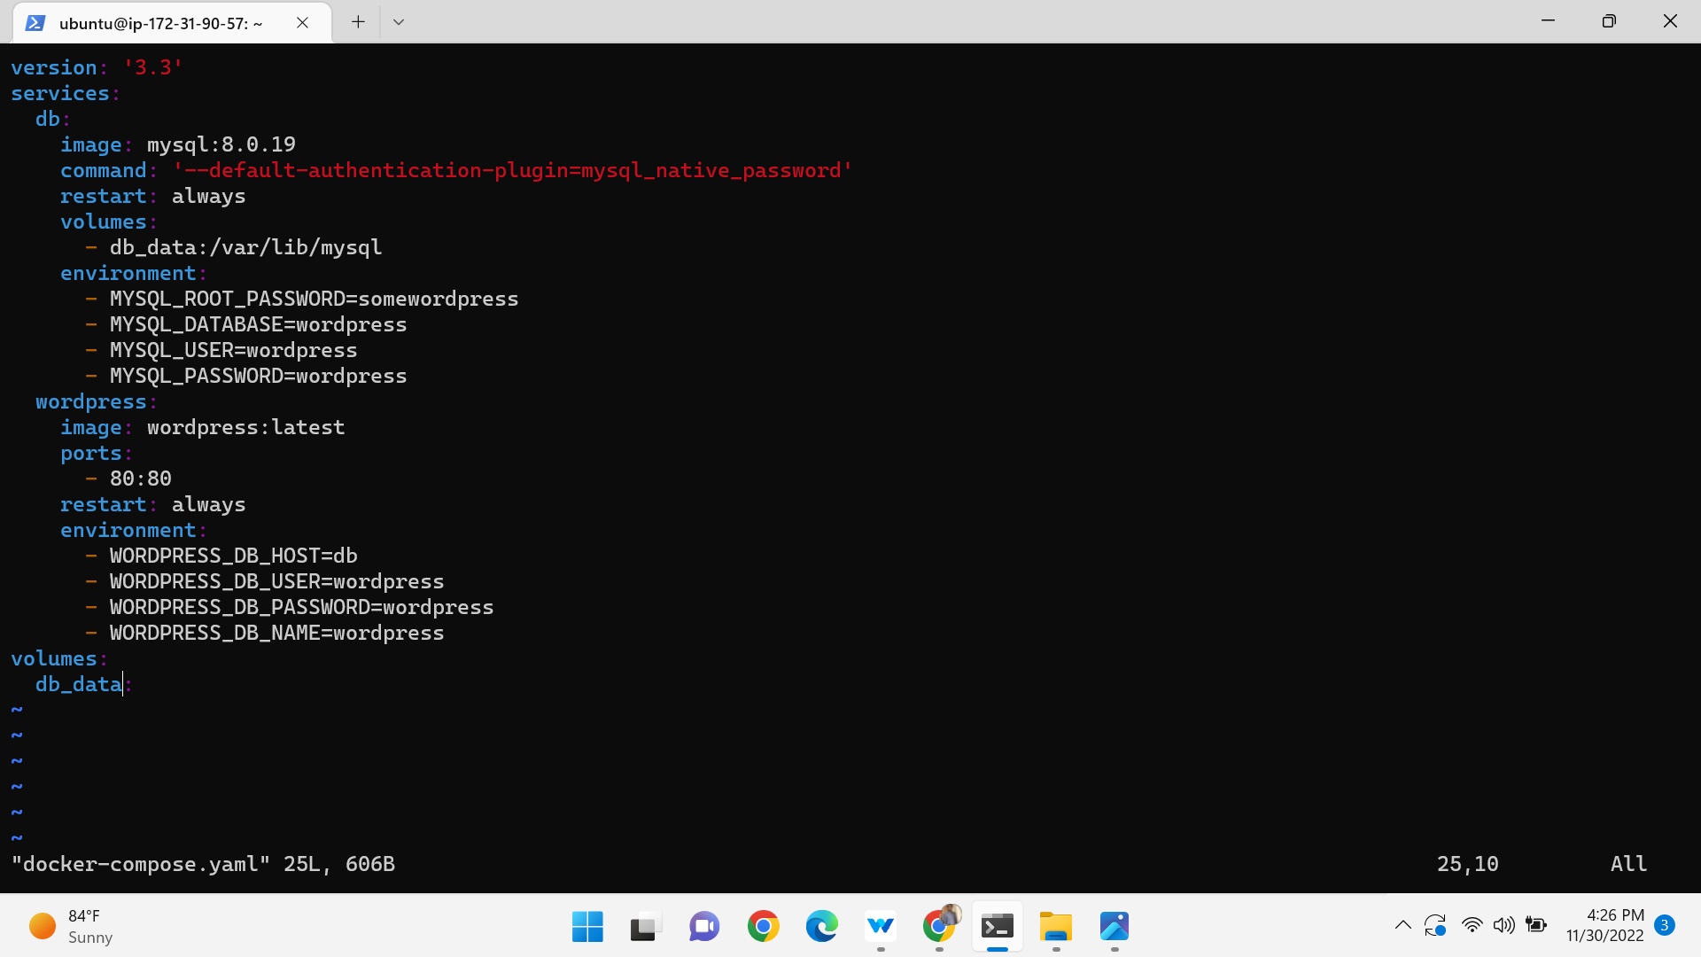

And check the file by using command

Sudo docker-compose up -d i.e we pulling the MYSQL images through wordpress

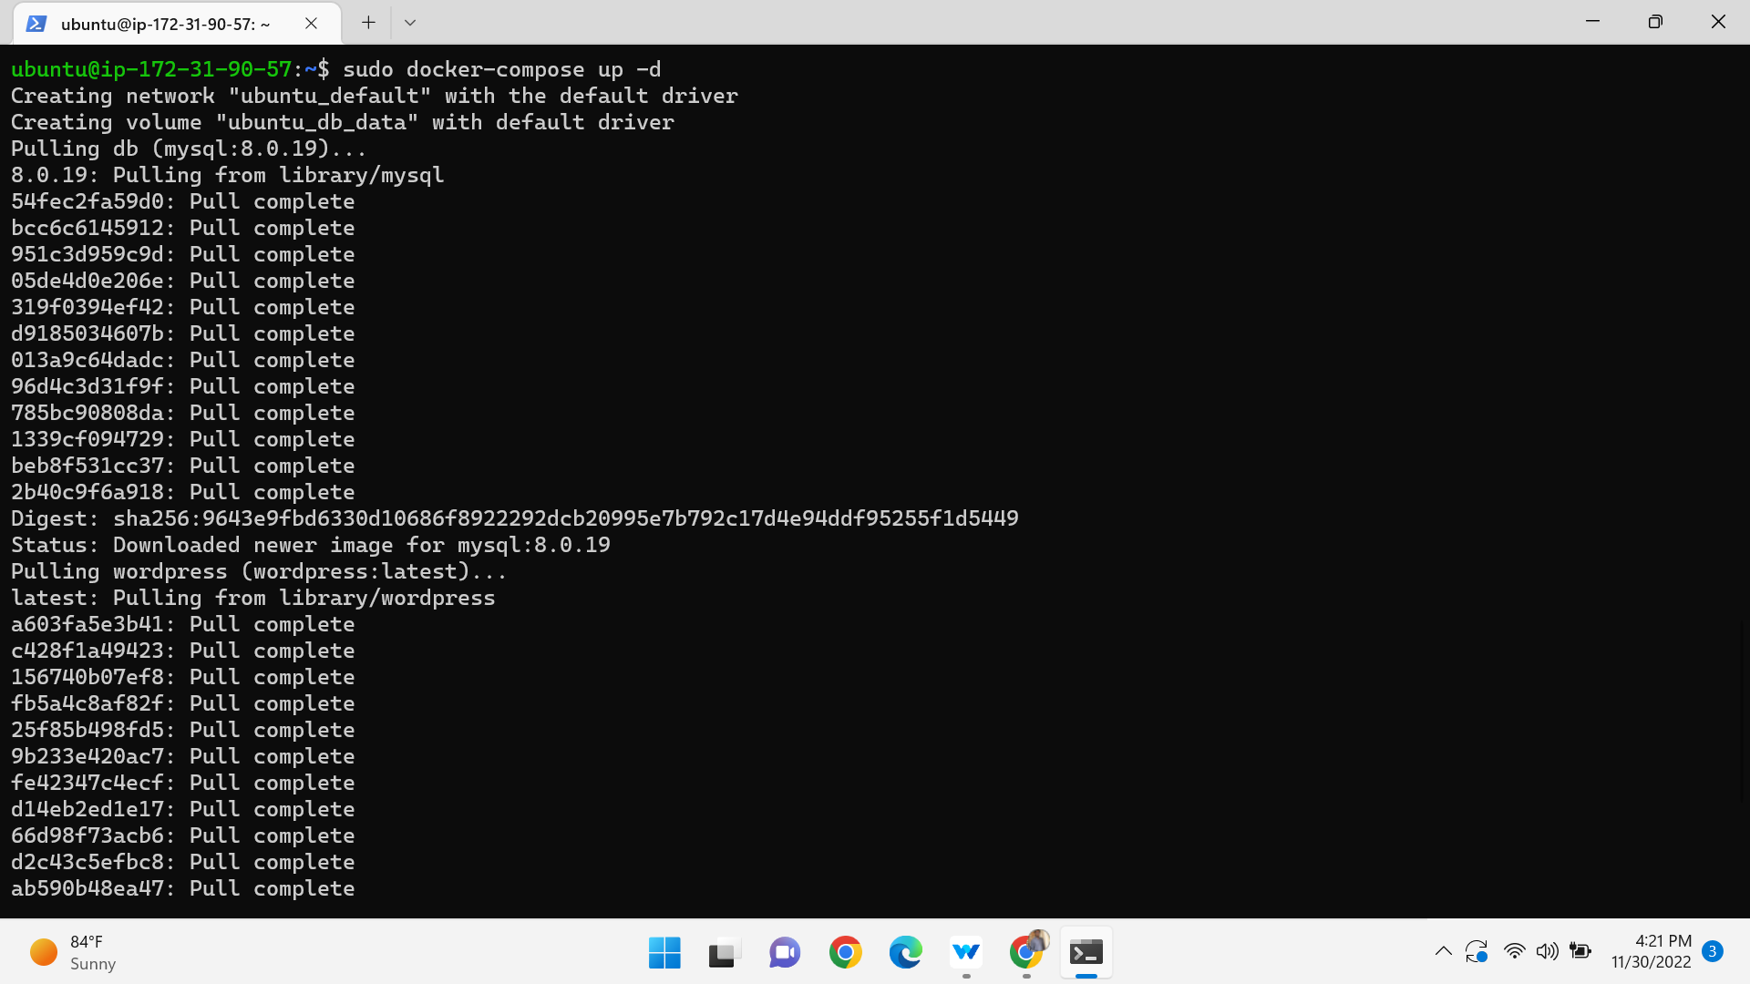and then copy the public ip address on the browser

